**Epilepsy Surgery Trends in the United States from 1990 to 2008  
Student Investigator:** David Ouyang **Sponsor:** Edward F. Chang, MD

**Research Question:** Guidelines for the medical management and surgical treatment of temporal lobe epilepsy (TLE), the most common localized epileptic disorder, has changed in the last twenty years. We looked at trends in the utilization of anterior temporal lobectomy (ATL) between 1990 and 2008 by datamining national databases to test whether clinical practice has changed following advances in literature and national society guidelines.

**Background:** It has been estimated that between 25 – 40% of epilepsy patients experience medically refractory seizures that are poorly controlled by anti-epileptic drugs [1-4]. In 2001, a randomized, controlled trial found that ATL performed superiorly to continued medical treatment after two failed medical regimens for TLE [5]. Subsequent guidelines by multiple professional societies have recommended surgical evaluation for medically-refractory TLE patients, but it is unknown whether clinical practice has changed accordingly [6]. Before this study, no investigation of national trends on TLE has been attempted and only single institution trends have been described [7].

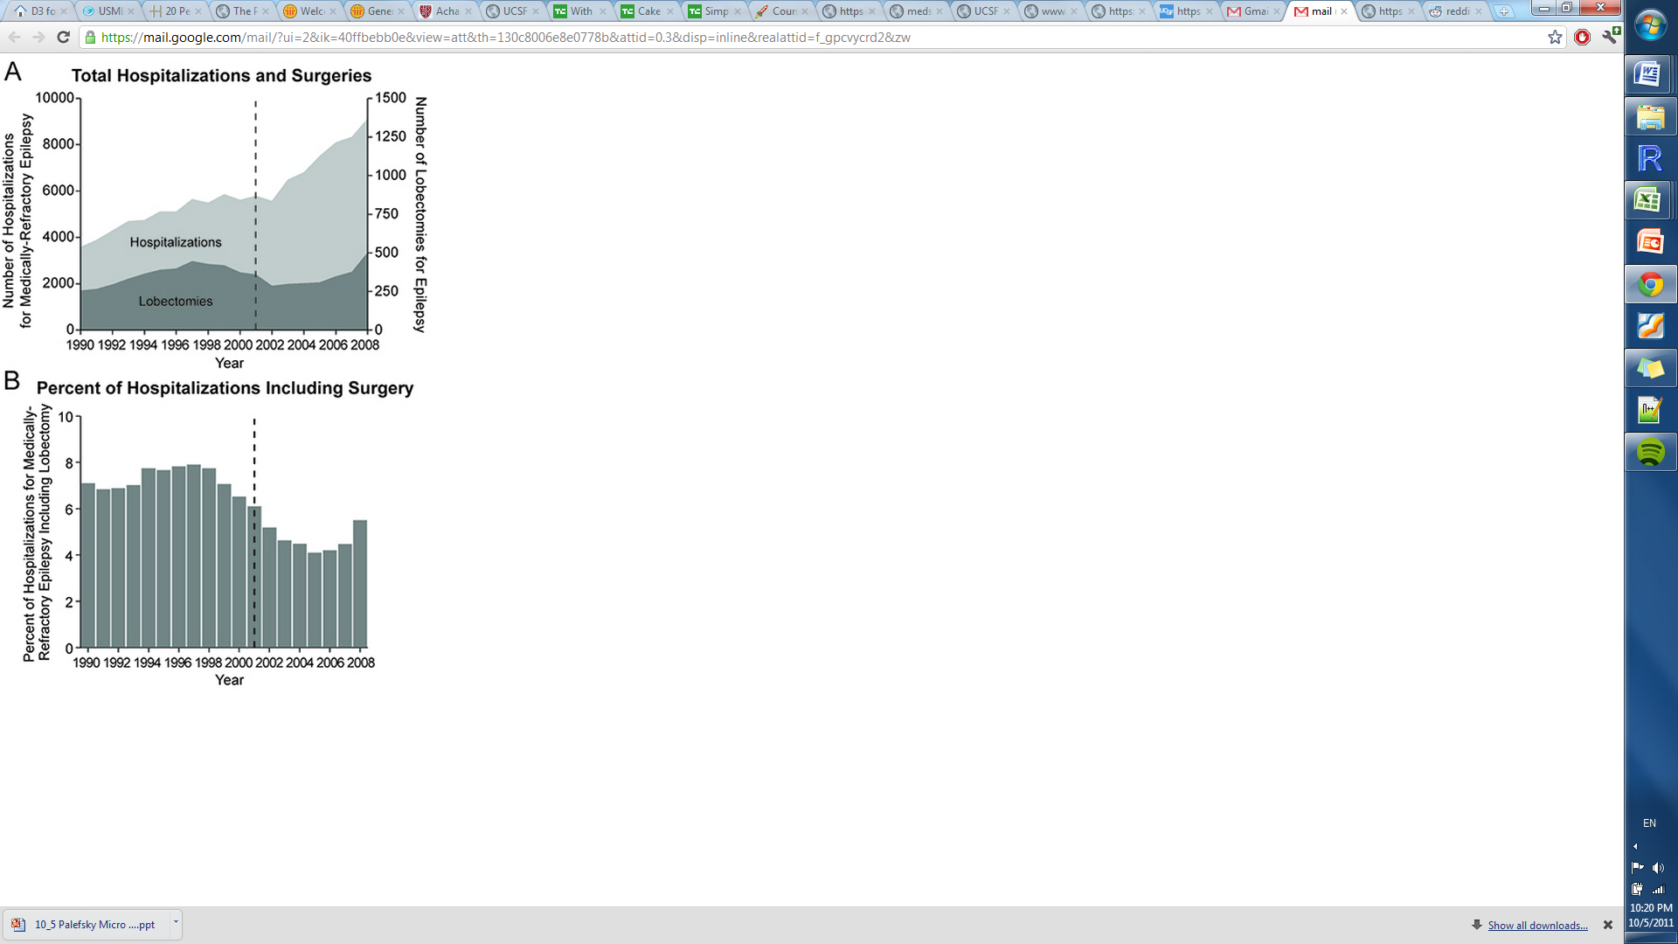**Methods:** A retrospective cohort study with time trends of patients admitted to US hospitals was performed using the National Inpatient Sample (NIS). A computer program was written in Python to extract all records of patients admitted for temporal lobe epilepsy (ICD-9 code: 345.41 and 345.51) and identify cases of anterior temporal lobectomy (ICD-9 code: 01.53). R and gglot2 was used to perform statistical analysis on time trends, patient demographics, and referral hospital characteristics.

**Results:** Weighted data revealed 112,026 national hospitalizations for TLE and 6,653 ATLs from 1990 to 2008. A trend of increasing TLE admissions over the study period was not accompanied by an increase in ATLs, producing a significant trend of decreasing ATL rates (P < 0.01). Factors underlying this trend included a decrease in TLE hospitalizations at the highest-volume epilepsy centers, and increased admissions to lower-volume hospitals less likely to perform the procedure. White patients were significantly more likely to receive ATL than racial minorities, and privately insured individuals were more likely to have surgery than those with Medicaid or Medicare.

**Conclusions:** Despite class I evidence and subsequent guidelines, the utilization of ATL for TLE has not increased from 1990 to 2008. Significant disparities exist in the surgical treatment of TLE related to race and insurance coverage. Medically-refractory TLE patients should be referred to a comprehensive epilepsy center for surgical evaluation.

**References**

1. Engel J, Jr. Surgical treatment for epilepsy: too little, too late? *JAMA.* Dec 3 2008;300(21):2548 2550.
2. Helmstaedter C, Kockelmann E. Cognitive outcomes in patients with chronic temporal lobe epilepsy. *Epilepsia.* 2006;47 Suppl 2:96-98.
3. Kwan P, Sperling MR. Refractory seizures: try additional antiepileptic drugs (after two have failed) or go directly to early surgery evaluation? *Epilepsia.* Sep 2009;50 Suppl 8:57-62.
4. Kwan P, Brodie MJ. Early identification of refractory epilepsy. *N Engl J Med.* Feb 3 2000;342(5):314-319.
5. Wiebe S, Blume WT, Girvin JP, Eliasziw M. A randomized, controlled trial of surgery for temporal-lobe epilepsy. *N Engl J Med.* Aug 2 2001;345(5):311-318.
6. Engel J, Jr., Wiebe S, French J, et al. Practice parameter: temporal lobe and localized neocortical resections for epilepsy: report of the Quality Standards Subcommittee of the American Academy of Neurology, in association with the American Epilepsy Society and the American Association of Neurological Surgeons. *Neurology.* Feb 25 2003;60(4):538-547.
7. Haneef Z, Stern J, Dewar S, Engel J, Jr. Referral pattern for epilepsy surgery after evidence-based recommendations: a retrospective study. *Neurology.* Aug 24 2010;75(8):699-704.